KIPTOO EZRA KIMOSOP
Bsccs/2024/43935
BIT 4139

Ethical Hacking
Week 6

Table of Content
Contents
Practical Task 1 3
Basic Vulnerability Scan 3
Practical Task 2 6
Vulnerability Research 6
Practical Task 3 8
Organizational Vulnerability Assessment Plan 8
Advanced Practical Task 10
Challenge Task 11
Vulnerability Management Framework 11
Student’s reflection 12

Practical Task 1

Basic Vulnerability Scan
Target Metasploitable 2 Laboratory Environment

Discover active hosts.
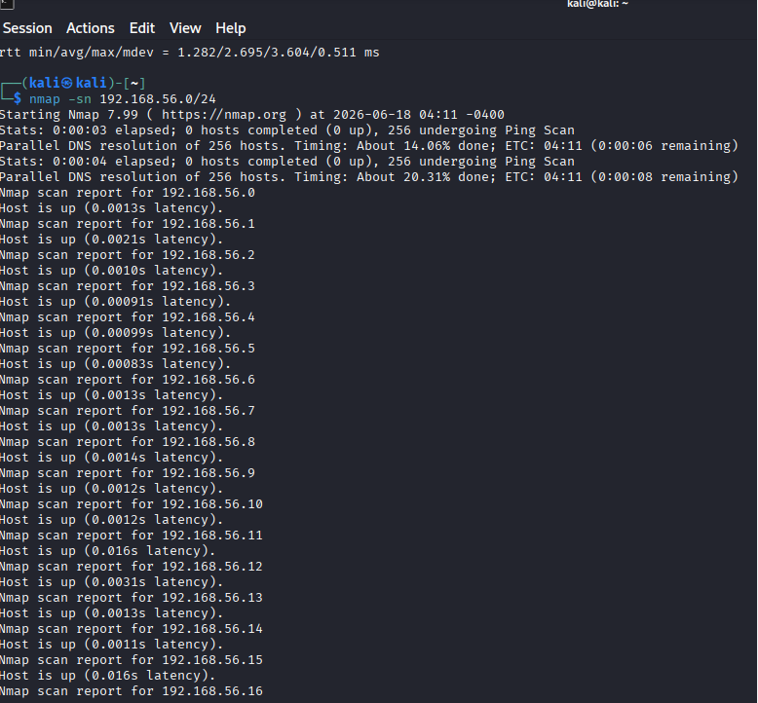

Identify open ports.
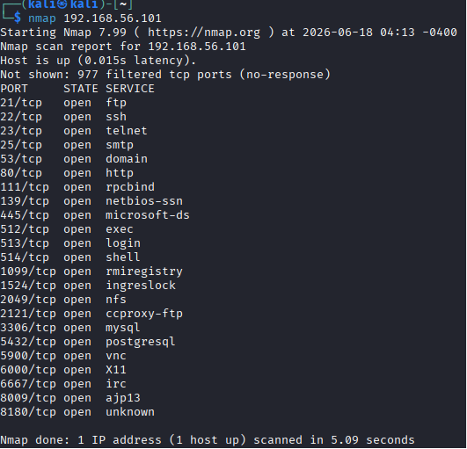
Service detection
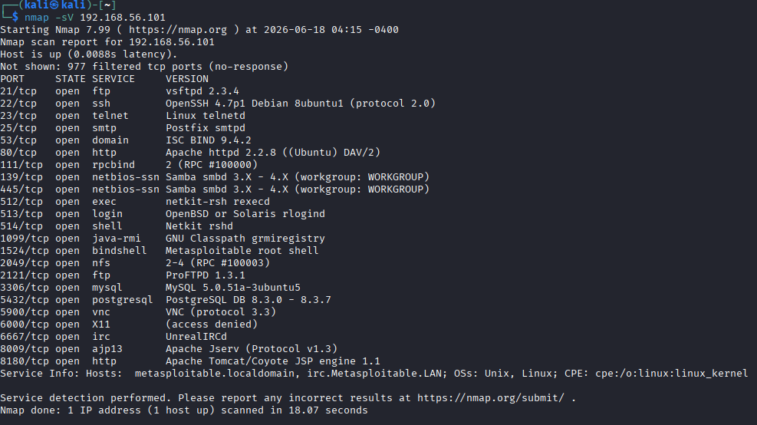

Os detection
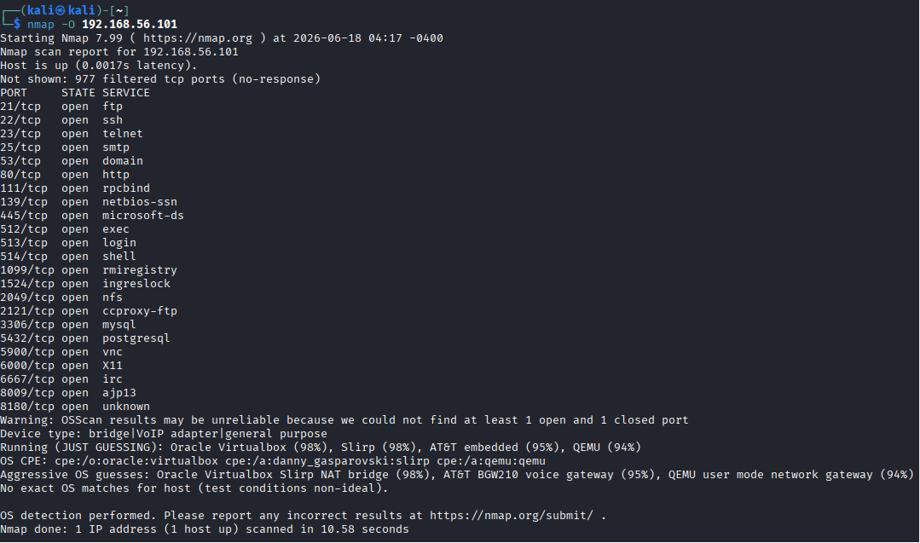

Document observations.
The scan identified multiple open services running on the target machine. Some services use outdated versions and may expose security risks if not properly secured.

Recommend security improvements.
Disable unnecessary services.
Update outdated software.
Close unused ports.
Apply security patches.
Restrict access using firewall rules.

Practical Task 2

Vulnerability Research

Go to the CVE database
Open:https://www.cve.org/
Search for a vulnerability (example: Apache, Windows, Linux,

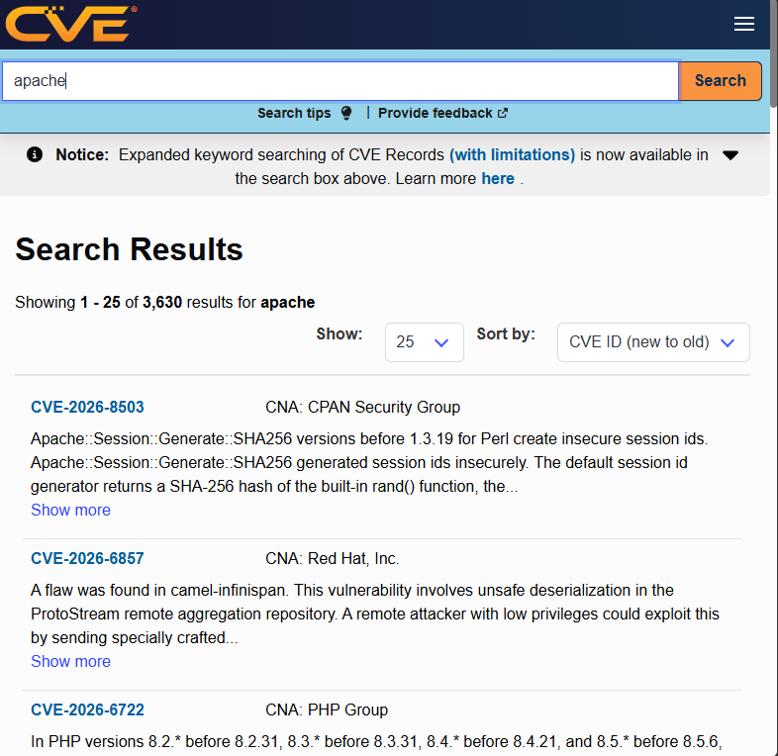

CVE Number | Description | Severity | Potential Impact | Mitigation strategy
CVE-2024-3094 | Backdoor vulnerability discovered in XZ Utils affecting Linux systems. | critical | Could allow unauthorized remote code execution. | Update XZ Utils packages and use trusted software repositories.
CVE-2024-1709 | Path traversal vulnerability in ConnectWise ScreenConnect. | Critical | Attackers could bypass authentication and access systems. | Upgrade ScreenConnect to a patched version and restrict access.
CVE-2024-21410 | Privilege escalation vulnerability in Microsoft Exchange Server. | High | Could allow attackers to gain higher privileges | Install Microsoft security updates and monitor Exchange systems.
CVE-2024-3400 | Command injection vulnerability in Palo Alto Networks PAN-OS GlobalProtect. | Critical | Could allow remote attackers to execute commands on devices | Apply vendor patches and restrict management access.
CVE-2023-4863 | Heap buffer overflow vulnerability in Google Chrome/WebP library. | high | Could lead to arbitrary code execution through malicious files. | Update browsers and affected libraries to the latest versions.

Practical Task 3

Organizational Vulnerability Assessment Plan
University Network
Scope:
- Student computers
- Servers
- Wi-Fi network
- Database systems
Tools:
- Nmap for finding open ports
- OpenVAS for vulnerability scanning
- Nikto for web testing
Schedule:
- Scan every month
- Review serious issues immediately
Reporting Procedure:
- Record vulnerabilities found
- Assign risk level (High/Medium/Low)
- Give recommendations
- Track fixes

Small Business
Scope:
Office computers, network devices, servers, websites, and employee accounts.
Tools:
Nmap for network scanning
OpenVAS for vulnerability scanning
Nikto for web assessment
Schedule:
Monthly vulnerability scans and regular security reviews.
Reporting Procedure:
Document identified vulnerabilities, assign risk levels, provide recommendations, and track remediation.
Hospital
Scope:
Patient information systems, medical devices, servers, databases, and network infrastructure.
Tools:
Nmap for identifying exposed services
OpenVAS for vulnerability detection
Nikto for web application testing
Schedule:
Regular scans monthly and immediate assessment of critical vulnerabilities.
Reporting Procedure:
Prepare reports showing vulnerabilities, risk impact, recommended fixes, and compliance concerns.
Financial Institution
Scope:
Banking systems, customer databases, servers, applications, and network security devices.
Tools:
Nmap for network discovery
OpenVAS for vulnerability assessment
Nikto for web security testing
Schedule:
Frequent vulnerability scans, security audits, and continuous monitoring.
Reporting Procedure:
Report vulnerabilities based on severity, assign responsible personnel, recommend mitigation actions, and monitor resolution progress.

Advanced Practical Task
Create a vulnerability tracking spreadsheet containing:
- Vulnerability Name
- Risk Level
- Status
- Assigned Personnel
- Resolution Date
Vulnerability Name | Risk Level | Status | Assigned Personnel | Resolution Date
Open SSH Service | medium | Open | Security Team | 25/06/2026
Outdated Apache Version | high | In progress | IT Administrator | 30/06/2026
Weak Password Policy | medium | resolved | System Admin | 20/06/2026
Unpatched Software | critical | open | Security engineer | 05/07/2026

Challenge Task
Design a Vulnerability Management Framework for an organization.
Include:
- Components
- Asset Inventory
- Scanning Schedule
- Risk Assessment Process
- Patch Management
- Reporting Procedures
- Continuous Monitoring

Vulnerability Management Framework
Asset Inventory
Maintain a list of all systems, devices, applications, and network resources. Record ownership and system details.
Scanning Schedule
Perform regular vulnerability scans using tools such as Nmap and OpenVAS. Critical systems should be scanned more frequently.
Risk Assessment Process
Identify vulnerabilities, assign severity levels (Critical, High, Medium, Low), and prioritize fixes based on risk.
Patch Management
Apply security updates and patches regularly. Test patches before deployment to avoid system disruption.
Reporting Procedures
Document findings, provide risk details, assign responsible personnel, and track remediation progress.
Continuous Monitoring
Continuously monitor systems for new vulnerabilities, configuration changes, and emerging threats.

Student’s reflection
This practical provided experience in vulnerability assessment through network scanning, service identification, CVE research, and vulnerability management planning. It improved understanding of security tools such as Nmap, risk assessment, reporting, and mitigation strategies. Challenges included interpreting scan results and organizing findings effectively. The activity highlighted the importance of identifying, prioritizing, and resolving vulnerabilities to strengthen system security.

